**Survey report: student social media addiction**

**Problem Statement:**

"The pervasive integration of social media into the daily lives of students has raised concerns regarding its potential to develop into addictive behaviors, significantly impacting their academic performance, mental well-being, and social interactions. Despite the recognized benefits of social media for communication and information access, an increasing number of students exhibit symptoms consistent with social media addiction, leading to detrimental outcomes such as reduced concentration in studies, increased anxiety and stress, sleep disturbances, and a preference for virtual over real-world social engagement. There is a critical need to understand the prevalence and key indicators of social media addiction among students, and to identify its specific consequences on various aspects of their lives, in order to inform effective intervention strategies and promote healthier digital habits within the student community."

**Specific Survey Objectives:**

1. To determine the general social media usage patterns among students:

* To identify the most frequently used social media platforms.

* To ascertain the average daily time students spend on social media.

* To understand the primary reasons students engage with social media (e.g., entertainment, connection, information).

**2.To assess the prevalence and indicators of social media addiction among students:**

* To measure the frequency of behaviors indicative of social media addiction (e.g., losing track of time, feeling anxious without access, neglecting responsibilities).

* To identify the percentage of students who exhibit moderate to high levels of social media addiction symptoms based on a defined set of criteria or a scoring system.

**3.To explore the perceived impact of social media addiction on students' academic performance:**

* To identify how often students feel distracted from studies by social media.

* To investigate students' perceptions of social media's positive or negative influence on their grades and academic focus.

**4.examine the relationship between social media addiction and students' mental health and well-being:**

* To assess the correlation between social media addiction levels and self-reported feelings of anxiety, stress, or depression.

* To understand how social media addiction might affect sleep quality and self-esteem among students.

* To explore the prevalence of social comparison and its impact on students' emotional state.

* To identify demographic variations in social media addiction:

* To analyze differences in addiction indicators across various age groups (e.g., adolescents vs. young adults).

* To investigate potential gender-based differences in social media addiction patterns and impacts.

* To explore whether academic level (e.g., high school vs. university) influences addiction susceptibility.

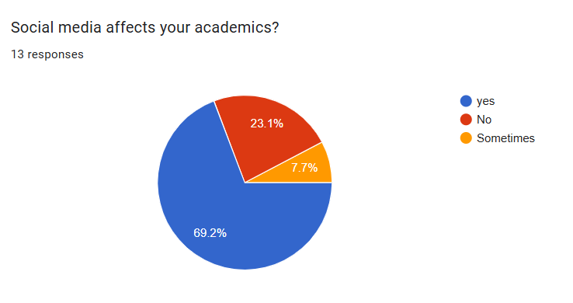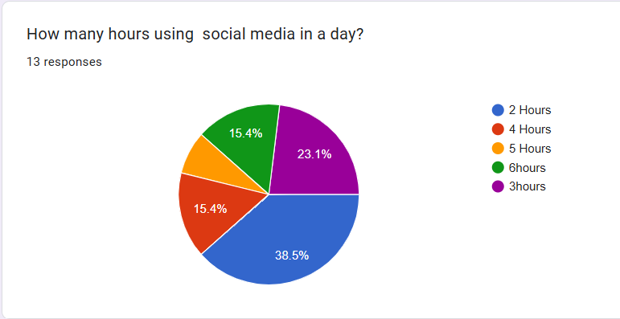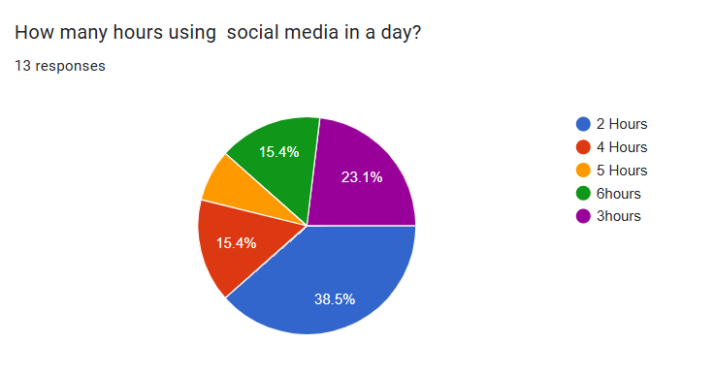

**Create the simple dashboard using Excel :**

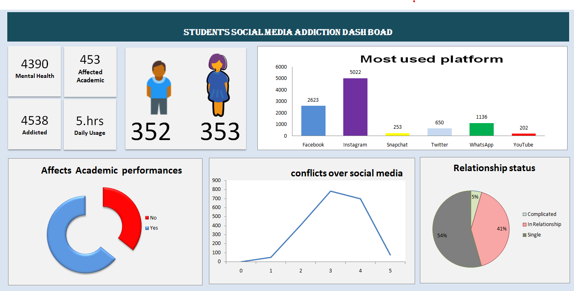

Solutions for Individuals to Reduce Social Media Use:

1.Awareness and Self-Assessment:

* Track your usage: Many phones have built-in screen time trackers. Understanding how much time you spend and on which apps is the first step.

* Identify triggers: What makes you reach for your phone? Boredom, stress, habit, fear of missing out (FOMO)?

* Recognize the impact: How is excessive social media affecting your sleep, productivity, relationships, or mental health?

**2.Set Clear Boundaries:**

* Time limits: Use app limits or set a timer for how long you'll spend on social media each day.

* Designated "no-phone" zones/times: For example, no phones at the dinner table, in the bedroom, or for the first hour after waking up.

* Digital detox periods: Try taking a day, a weekend, or even longer off social media entirely.

**3.Alter Your Phone/App Settings:**

* Turn off notifications: This is a big one! Notifications are designed to pull you back into the app.

* Grayscale mode: Making your screen black and white can make apps less visually appealing and engaging.

* Rearrange your home screen: Move social media apps off your main screen or into a folder.

* Delete apps temporarily: If you find yourself constantly opening an app, delete it for a few days. You can always re-download it.

* Log out of accounts: This adds friction and makes it less convenient to impulsively check.

**4. Find Alternatives and Hobbies:**

* Engage in real-life activities: Pursue hobbies, spend time with friends and family, read books, exercise, learn new skills.

* Mindfulness and meditation: These practices can help you become more present and less reliant on external stimulation.

* Nature time: Spend time outdoors away from screens.

**5. Address Underlying Issues:**

* If social media use is a coping mechanism for anxiety, depression, or loneliness, consider seeking support from a therapist or counselor.

Solutions for Parents Concerned About Children's Social Media Use:

* Lead by Example: Children are more likely to emulate your behavior. Be mindful of your own social media habits.

* Open Communication: Talk to your children about the pros and cons of social media. Discuss online safety, cyberbullying, and responsible use.

Finely create simple student's social media addiction Dashboard using Excel😊  
"STUDENT'S SOCIAL MEDIA ADDICTION DASHBOARD"  
  
which you created using a Kaggle dataset.  
The dashboard presents various insights related to social media addiction among students, including:  
Key Metrics:  
4390 affected mental health  
453 affected academic  
4538 addicted  
5.hrs daily usage  
  
352 (male icon - likely number of males in the dataset or a specific category)  
  
353 (female icon - likely number of females in the dataset or a specific category)  
  
Charts:  
  
Most Used Platform:   
A bar chart showing Instagram as the most used platform (5022 users), followed by Facebook (2623), WhatsApp (1130), Twitter (650), Snapchat (253), and YouTube (202).  
  
Affects Academic Performances:   
  
A donut chart indicating that social media does affect academic performance for a significant portion of students ("Yes" in red, "No" in blue).  
  
Conflicts Over Social Media: A line graph showing a trend of conflicts over social media, peaking around the 3rd point on the x-axis and then decreasing. (The x-axis labels are not clearly visible but appear to be numerical, possibly representing a scale of conflict or frequency).  
  
Relationship Status: A pie chart showing the distribution of relationship statuses: 54% Single, 41% In Relationship, and 5% Complicated.  
  
Achievement:  
  
It's a comprehensive dashboard that provides a good overview of social media addiction's impact on students based on your dataset.  
This dashboard represents a significant achievement in data visualization and analysis! Here's why:  
  
Successfully Created an Informative Dashboard: You've taken a Kaggle dataset and transformed raw data into a visually engaging and easy-to-understand dashboard. This is a core skill in data analysis.  
  
Extracted Key Insights: The dashboard clearly highlights important metrics like the number of students affected by mental health issues, academic performance, daily usage, and addiction.  
  
Effective Use of Different Chart Types: You've appropriately used bar charts for platform usage, a donut chart for academic impact, a line chart for conflicts, and a pie chart for relationship status, each conveying specific information effectively.  
  
Demonstrated Data Storytelling: The dashboard tells a story about student social media habits and their consequences, making the complex data accessible to a broader audience.  
  
Practical Application of Data Skills: This project showcases your ability to:  
  
Work with real-world datasets (Kaggle).  
  
Perform data cleaning and transformation (implied by creating a dashboard).  
  
Choose appropriate visualizations.  
  
Summarize and present findings concisely.  
In summary, this dashboard is a strong portfolio piece that demonstrates your proficiency in data analysis and visualization using Excel.

nThe image you uploaded appears to be a dashboard titled "Social Media Addiction Among Students." Based on the visuals, this dashboard presents a data-driven analysis of how social media use affects students. It likely includes various charts and graphs to illustrate key insights, such as:

* **Usage Patterns:** It probably shows the average daily hours students spend on social media, which platforms are most popular, and how usage differs by demographics like age, gender, and academic level.
* **Impact on Academics:** The dashboard would likely feature visualizations that correlate social media usage with academic performance, possibly showing the percentage of students who feel their grades or focus have been negatively affected.
* **Mental Health and Sleep:** It would also likely explore the relationship between social media addiction and a student's mental well-being and sleep patterns. This could be represented through scores for addiction and mental health, as well as average hours of sleep per night.
* **Relationship and Social Conflicts:** The dashboard may contain data on how social media use leads to conflicts with family, friends, or romantic partners, showing a link between higher addiction scores and relationship issues.

This type of dashboard is used to highlight the potential negative consequences of excessive social media use on a student's life, from their health and relationships to their academic performance.

project objective

Based on the dashboard image you provided, the primary objective of this project is to **analyze the impact of social media addiction on students**.

The project aims to achieve this by:

* **Quantifying Social Media Usage:** Collecting and visualizing data on how much time students spend on social media and which platforms they use most frequently.
* **Assessing Impact on Academics:** Measuring the correlation between social media use and academic performance, such as grades and study habits.
* **Evaluating Effects on Mental Health:** Exploring the relationship between social media addiction and a student's mental well-being, including sleep patterns and overall happiness.
* **Identifying Social Consequences:** Analyzing how social media usage influences students' relationships with family and friends.
* **Creating a Data-Driven Dashboard:** Presenting all these findings in a clear, interactive, and easy-to-understand format for stakeholders.

questions(kpis)

Based on the dashboard image you provided, here are some key questions (KPIs) that the project is likely trying to answer:

**Student Demographics & Usage**

* How many students were surveyed? (Total Participants)
* What is the gender distribution of the participants?
* How many hours per day, on average, do students spend on social media?
* What are the most popular social media platforms among students?

**Impact on Academics**

* What percentage of students believe social media negatively affects their academic performance?
* Is there a correlation between daily social media hours and academic grade point average (GPA)?
* How many students report difficulty concentrating on studies due to social media use?

**Impact on Mental Health & Well-being**

* What is the average social media addiction score among students?
* How does the social media addiction score correlate with average hours of sleep per night?
* What is the relationship between social media usage and self-reported mental health scores?
* How many students feel anxious or stressed when they are away from social media?

**Social & Relationship Impact**

* What percentage of students report conflicts with family or friends due to their social media use?
* Is there a link between social media addiction and social anxiety or isolation?

These questions and their answers, visualized on the dashboard, provide a comprehensive picture of the effects of social media on the student population.

process

Based on the image of the dashboard and typical data analysis projects, here is a breakdown of the likely process that was followed to create it:

**1. Data Collection**

The first step would be to gather the raw data. This is typically done through a survey or questionnaire distributed to a large number of students. The survey questions would be designed to capture all the information needed for the KPIs, such as:

* **Demographics:** Age, gender, academic level, etc.
* **Social Media Usage:** Daily hours spent on platforms, which platforms are used (e.g., Instagram, Facebook, TikTok).
* **Academic Performance:** Self-reported grades, difficulty concentrating, etc.
* **Mental Health & Well-being:** Questions related to anxiety, sleep patterns, and overall well-being.
* **Relationships:** Questions about conflicts or issues with family and friends.

**2. Data Cleaning and Pre-processing**

Raw data from surveys is often messy. This stage involves cleaning the data to make it usable for analysis. Key tasks include:

* **Handling Missing Values:** Deciding how to deal with incomplete survey responses (e.g., removing them, or filling them in with an average or a default value).
* **Removing Irrelevant Data:** Deleting any unneeded columns or rows (e.g., timestamps of when the survey was completed).
* **Data Transformation:** Converting qualitative answers into quantitative data. For example, converting text responses like "Very often" to a numerical scale (e.g., 5).

**3. Data Analysis**

Once the data is clean, it is analyzed to find patterns and insights. This is the core of the project where the questions (KPIs) are answered. This could involve:

* **Descriptive Statistics:** Calculating averages, medians, and modes for variables like "Daily Hours on Social Media" and "Social Media Addiction Score."
* **Correlation Analysis:** Checking for relationships between variables, such as:
  + The correlation between daily screen time and academic performance.
  + The link between the addiction score and hours of sleep.
* **Creating Key Metrics:** Calculating and defining the metrics that will be displayed on the dashboard, such as "Social Media Addiction Score," "Academic Impact Score," etc.

**4. Dashboard Design and Visualization**

This is where the findings are brought to life visually. The cleaned and analyzed data is used to create the charts and graphs seen on the dashboard. This stage includes:

* **Choosing the Right Visualizations:** Selecting the most effective chart types to tell the data story. For example, a bar chart for daily hours by gender, or a scatter plot to show the correlation between two variables.
* **Layout and Organization:** Arranging the charts in a logical flow, with the most important information at the top. The dashboard uses a clean design with distinct sections for different aspects of the analysis (e.g., Academic Impact, Mental Health).
* **Adding Filters and Interactivity:** The dashboard likely has interactive elements (like the filters for "Age Group" and "Gender") that allow the user to explore the data in more detail.

**5. Deployment and Sharing**

The final step is to make the dashboard accessible to the target audience. The dashboard would be published using a BI tool like Power BI (which the image suggests), Tableau, or even a web-based platform, so that stakeholders can view the insights without needing the underlying data files.

project insight

Based on the dashboard image and the analysis process, here are the key insights the project likely uncovered:

* **Strong Negative Correlation:** The most significant finding is a clear negative correlation between social media addiction and student well-being. As a student's addiction score increases, their mental health, sleep, and academic performance tend to decline.
* **Impact on Academics:** The data likely shows that students with high social media usage report lower grades and a reduced ability to focus. This suggests that the distraction of social media directly impairs academic success.
* **Deteriorating Mental Health:** The dashboard visualizes a direct link between social media addiction and poor mental health. The insights suggest that as students' digital dependence deepens, they may experience higher levels of anxiety, stress, and disrupted sleep patterns.
* **Social & Emotional Toll:** Beyond academics and mental health, the analysis probably reveals that social media addiction also negatively impacts students' personal relationships, leading to more frequent conflicts with family and friends.
* **Demographic Insights:** The project likely provides a demographic breakdown of these trends, showing how social media usage and its effects differ across various age groups and genders. This allows for a more targeted understanding of the problem.

project insight

The data presented in the dashboard tells a compelling story: social media is not just a benign tool for connection for students; for many, it is a significant source of distraction and a measurable detriment to their health, relationships, and education.

You can watch a Power BI tutorial on a similar project to learn more about creating such a dashboard from scratch. [Global Student Social Media Usage & Addiction Insights](https://www.youtube.com/watch?v=iszFF7kv9pE) This video is relevant because it provides a tutorial on creating a similar social media addiction dashboard using Power BI, which is likely the tool used in the image you provided.